Q1: Although he was a prolific artist, Pablo Picasso painted only 1,000 canvases during the "Blue Period". Picasso is now dead, and all his Blue Period works are currently on display in museums and private galleries.

a) Draw a supply curve for Picasso Blue Period works. Why is this supply curve different from ones you have seen?

*There are no more Picasso Blue Period works available. Hence the supply curve is a vertical line at the quantity 1,000.*

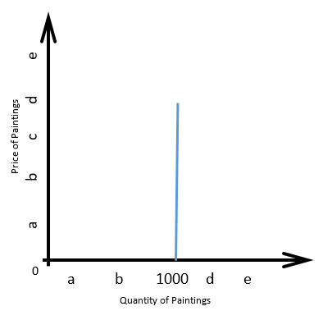Diagram:

b) Given the supply curve from part a, the price of a Picasso Blue Period work will be entirely dependent on what factor(s)? Draw a diagram showing how the equilibrium price of such work is determined.

*Since supply is fixed, the price of a Picasso Blue Period work is entirely determined by demand.  
Any change in demand is fully reflected in a change in price.*

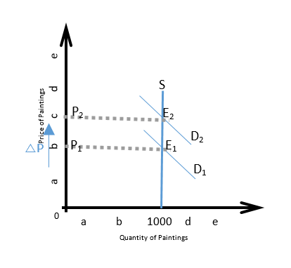Diagram:

c) Suppose rich art collectors decide that is essential to acquire Picasso Blue Period art for their collections. Show the impact of this on the market for these paintings.

*This results in a rightward shift of the demand curve for these works from D1 to D2, and the equilibrium changes from E1 to E2. But since no more works are available, this increase in demand simply results in an increase in the equilibrium price.*

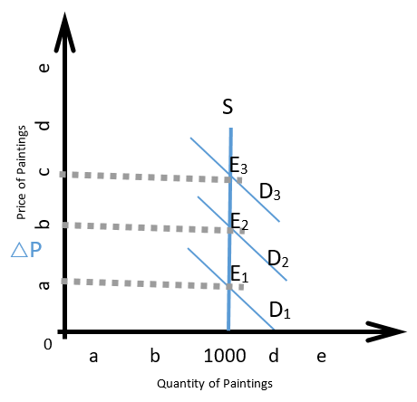Diagram

Q2: Explain why asymmetric information causes a market failure [hint: "market for lemons"]

Asymmetric information leads to failure of market. For example,

when buyers of product are not sufficiently informed, they are not able to determine

the true quality of product at the time of purchase. As a result, most buyers start

believing that most of the units of the good that enter in the market are of low

quality. [ Adverse Selection]

Similar problem may arise if the seller knows less than the buyer. When the  
sellers are not significantly informed, they are not able to differentiate between the  
genuine and the non-genuine buyers. To avoid the risk of loss they may refuse to  
sell their product to a particular category of buyers.[ Moral Hazard]

For example, the market of cars (New cars and Used Cars)

Q3: The accompanying table shows the supply and demand schedules for used copies of the third edition of the textbook Economics (Krugman and Wells). The supply schedule is derived from offers at Amazon.com. The demand schedule is hypothetical.

|  |  |  |
| --- | --- | --- |
| Price of book | Quantity of book demanded | Quantity of book supplied |
| $55 | 50 | 0 |
| 60 | 35 | 1 |
| 65 | 25 | 3 |
| 70 | 17 | 3 |
| 75 | 14 | 6 |
| 80 | 12 | 9 |
| 85 | 10 | 10 |
| 90 | 8 | 18 |
| 95 | 6 | 22 |
| 100 | 4 | 31 |
| 105 | 2 | 37 |
| 110 | 0 | 42 |

a) Calculate [consumer and producer surplus](https://moodle.unive.it/mod/resource/view.php?id=39436) at the equilibrium in this market.

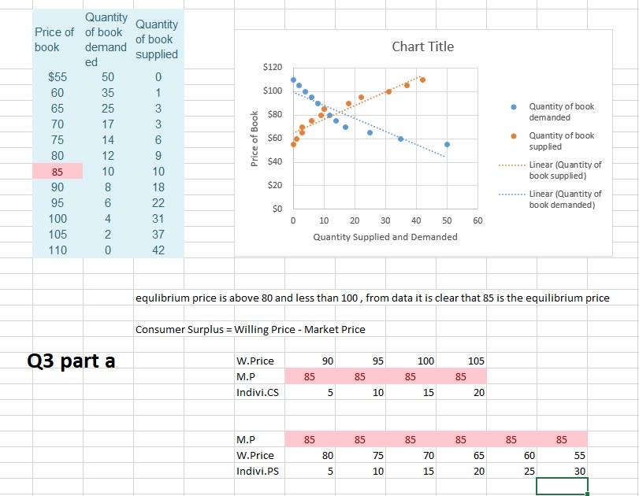

b) Now the fourth edition of the textbook Economics becomes available. As a result, the willingness to pay of each potential buyer for a second-hand copy of the third edition falls by $20. In a table, show the new demand schedule and again calculate [consumer and producer surplus](https://moodle.unive.it/mod/resource/view.php?id=39436) at the new equilibrium.

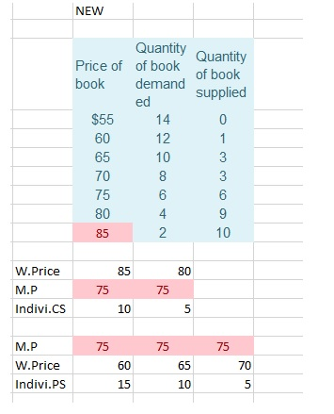

Q4: The market of cheese in Germany has an equilibrium quantity of 100kg at an equilibrium price of €2/kg. Suppose the government imposes a binding price floor of €5/kg.

a) Draw a supply-and-demand diagram to show graphically the effect of this policy on the price and quantity of cheese sold (you do not need to compute the new price and quantity).

b) Using different colors or different labels, show how the total surplus changes and how it is  
redistributed between consumers and producers. Is there a deadweight loss in total surplus?

